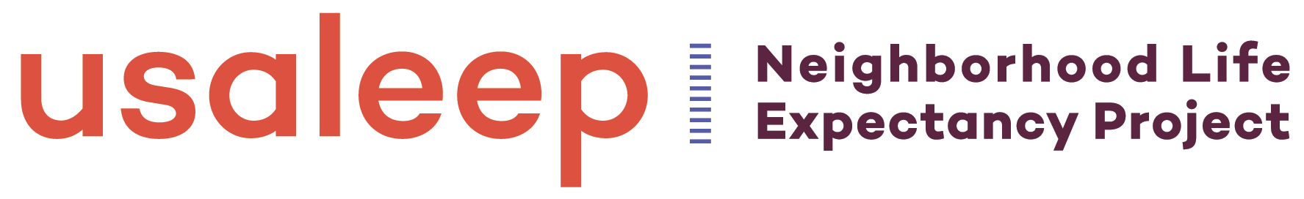

Embargoed for Release Contact:
Monday, September 10, 2018

10:00 a.m. EDT

Life Expectancy Estimates Available Neighborhood-by-Neighborhood in X State
Census Tract-Level Data can help leaders, advocates, residents create healthier communities

(Insert City, State) For the first time ever, public health officials, community leaders, and others working to improve health in [state] can access census tract-level data to measure and compare differences in life expectancy neighborhood-by-neighborhood. The United States Small-Area Life Expectancy Estimates Project (USALEEP) is a joint effort of the National Association for Public Health Statistics and Information Systems (NAPHSIS), the Centers for Disease Control and Prevention’s National Center for Health Statistics (NCHS), and the Robert Wood Johnson Foundation (RWJF).

These census tract-level life expectancy estimates–based on state death records and population estimates from the U.S. Bureau of the Census–have previously been unavailable nationwide. Access to estimates like these helps public health experts quantify how people living just a few miles apart can have vastly different opportunities for a long life. With this kind of information, community leaders can examine the factors that may be influencing differences in longevity–such as access to health care, safe and affordable housing, educational opportunities, and other factors that impact the health of community members–and target solutions more effectively.

Here in {state], the data show [add 2-4 examples of what the data show in terms of life expectancy for that state/locality]

Some ideas to consider:
- What are some of the census tracts in the state with the highest and lowest life expectancy estimates and do they have any other demographic characteristics in common?
- Are there any areas where two neighboring or very closely positioned census tracts are at the opposite ends of the scale (e.g. within one city or county}?
- Are there consistent differences in life expectancy estimates between rural and urban counties?
Although county-, city-, and ZIP code-level data have provided similar information, they often don’t tell the full story as neighborhoods right next to each other–located within the same ZIP code, city, or county–can provide drastically different opportunities for health and well-being. Census tract-level data offer information on a much smaller and targeted group of people making it easier to create a more complete picture of health at a local level. Census tracts cover an average of 4,000 people who typically have similar characteristics, such as social and economic status. Data available at this very granular level can help to more effectively target efforts to remove the barriers standing in the way of health and opportunity.

Hospitals, for example, can use the data to help create community health assessment plans that will identify areas most in need. Community development financial institutions can use these data to help decide which neighborhoods most need their investment dollars to fund health clinics, schools, and other projects. Community members can use the data to guide conversations about what is causing life expectancy disparities in their neighborhood and what changes they want to address those challenges, such as better public transportation, access to healthy food, or job training opportunities.

[Quote from local health official on why this tool is important for their work]

“Everyone deserves a fair shot at living a long life, but as these data show, that isn’t happening,” said Oktawia Wojcik, Program Officer at the Robert Wood Johnson Foundation. “These very localized data give us a more robust understanding of where there are disparities in life expectancy and the tangible things we can do to improve conditions in neighborhoods to enable people to live longer.”

For more information on USALEEP and to access life expectancy estimates for your neighborhood, please visit https://rwjf.org/lifeexpectancy or the [name of state or local health department] at [URL] for more information about this project. And for opportunities to take action locally, the County Health Rankings' What Works for Health is a searchable tool providing evidence-informed policies, programs, systems, and environmental changes that can make a difference locally. CDC’s Division of Community Health website also provides examples of communities taking action to improve the health of their residents.
###

About the National Association for Public Health Statistics and Information Systems
The National Association for Public Health Statistics and Information Systems (NAPHSIS) is the national nonprofit organization representing the state vital records and public health statistics offices in the United States. Formed in 1933, NAPHSIS brings together more than 250 public health professionals from each state, the five territories, New York City, and the District of Columbia. For more information, visit www.naphsis.org. Follow NAPHSIS on Twitter or on Facebook for regular updates.

About the Centers for Disease Control and Prevention
The Centers for Disease Control and Prevention (CDC) works 24/7 saving lives, protecting people from health threats, and saving money through prevention. Whether these threats are global or domestic, chronic or acute, curable or preventable, natural disaster or deliberate attack, CDC is the nation’s health protection agency.
About the National Center for Health Statistics
The National Center for Health Statistics (NCHS) is the principal health statistics agency in the United States, compiling statistical information to guide actions and policies to improve the health of all people. NCHS is a unique public resource for health information and a critical element of public health and health policy. For more information, visit https://www.cdc.gov/nchs.

About the Robert Wood Johnson Foundation
For more than 40 years the Robert Wood Johnson Foundation has worked to improve health and health care. We are working with others to build a national Culture of Health enabling everyone in America to live longer, healthier lives. For more information, visit www.rwjf.org. Follow the Foundation on Twitter at www.rwjf.org/twitter or on Facebook at www.rwjf.org/facebook.

###

